Arson Heat Map

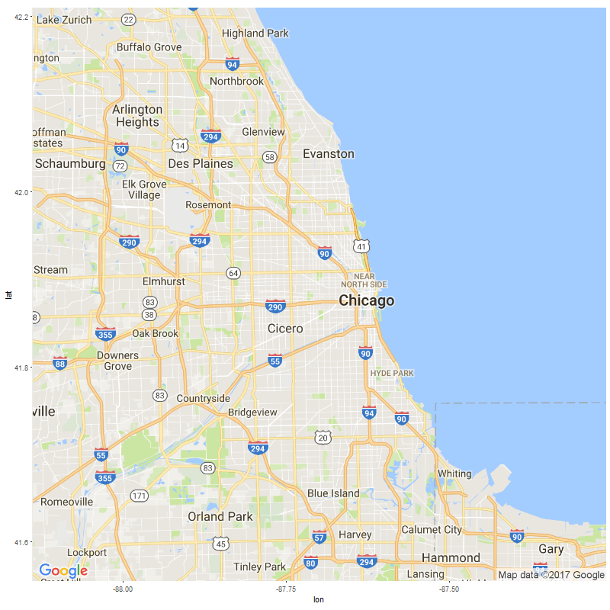

Assault Heat Map



Battery Heat Map



Burglary Heat Map

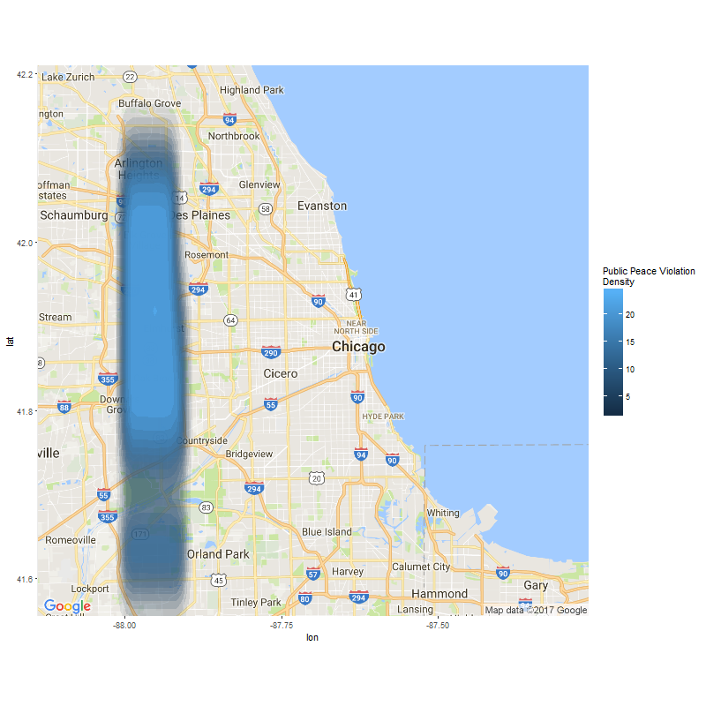

Criminal Damage Heat Map

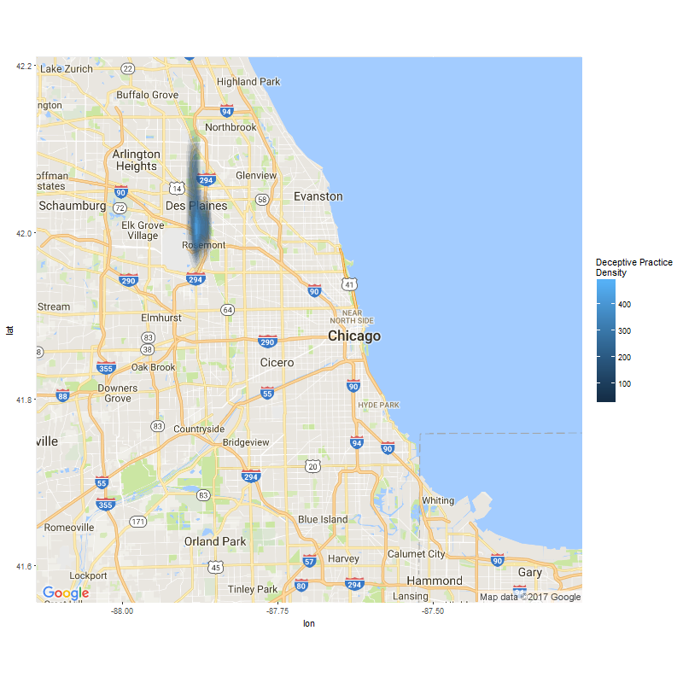

Criminal Sexual Assault Heat Map



Criminal Trespass Heat Map



Deceptive Practice Heat Map



Gambling Heat Map



Homicide Heat Map



Interference with a Public Officer Heat Map



Intimidation Heat Map



Kidnapping Heat Map



Liquor Law Violation Heat Map



Motor Vehicle Theft Heat Map



Narcotics Heat Map



Non-Criminal Offense Heat Map



Obscenity Heat Map



Offense Involving Children Heat Map

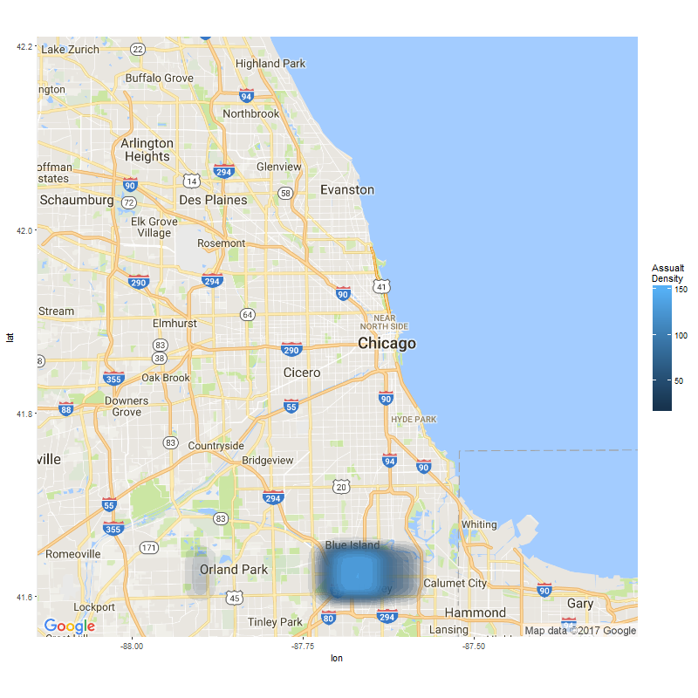

Other Offense Heat Map

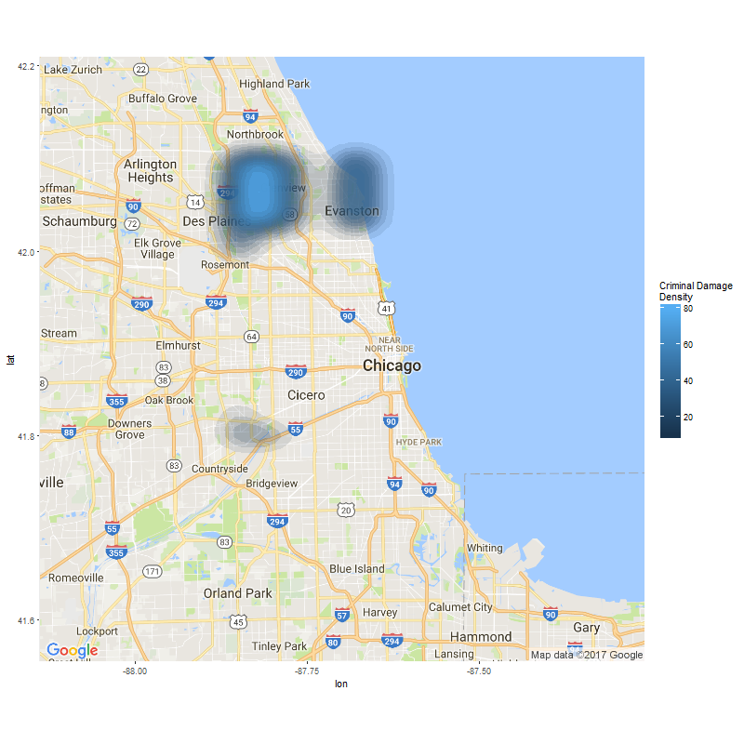

Prostitution Heat Map



Public Peace Violation Heat Map



Public Indecency Heat Map

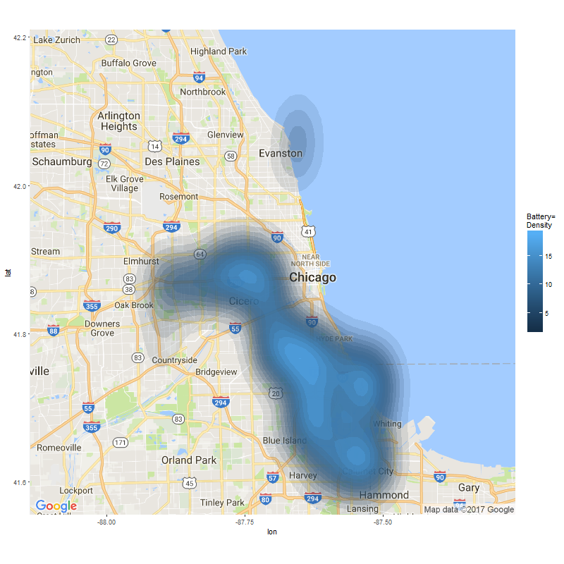

Robbery Heat Map



Sexual Offense Heat Map



Stalking Heat Map



Theft Heat Map



Weapons Violation Heat Map

